CS436 Chat room Project Report

Name: Kyungbin Lee, Sebastian Partow

Step1:

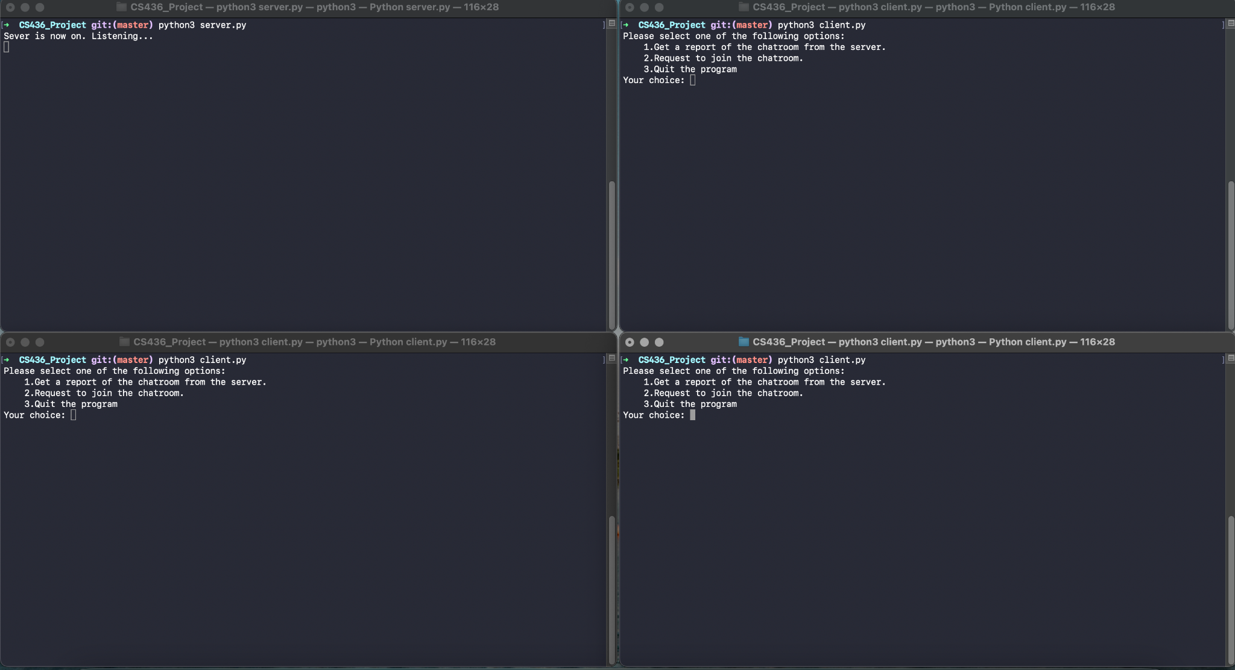

Step 2:

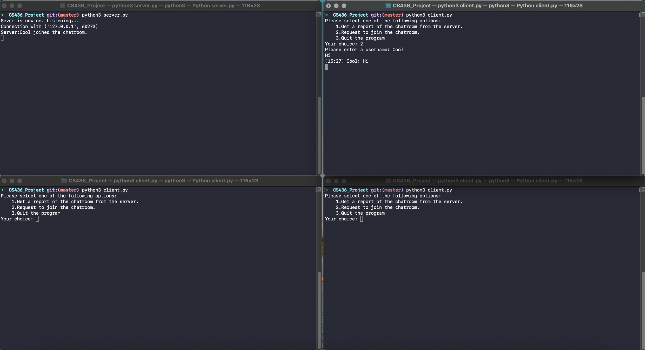

Step 3:

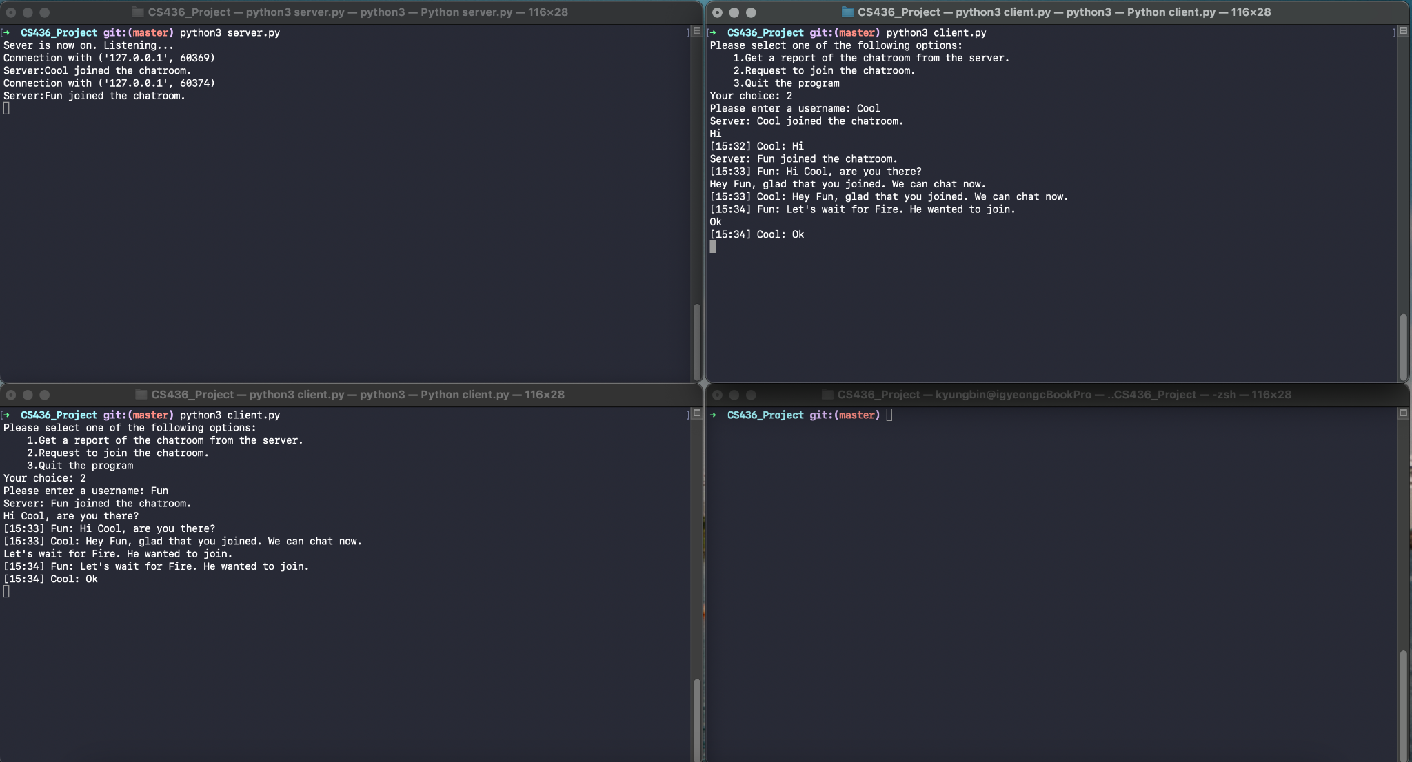

Step 4:

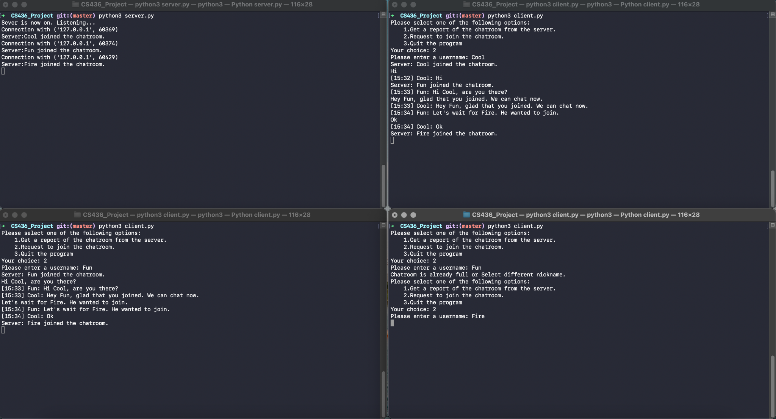

Step 5:

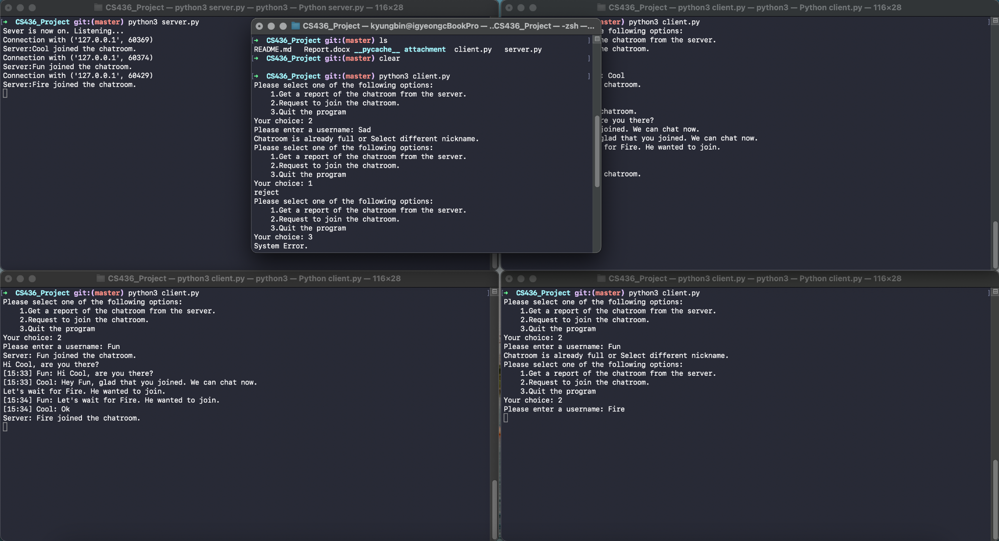

Step 6:

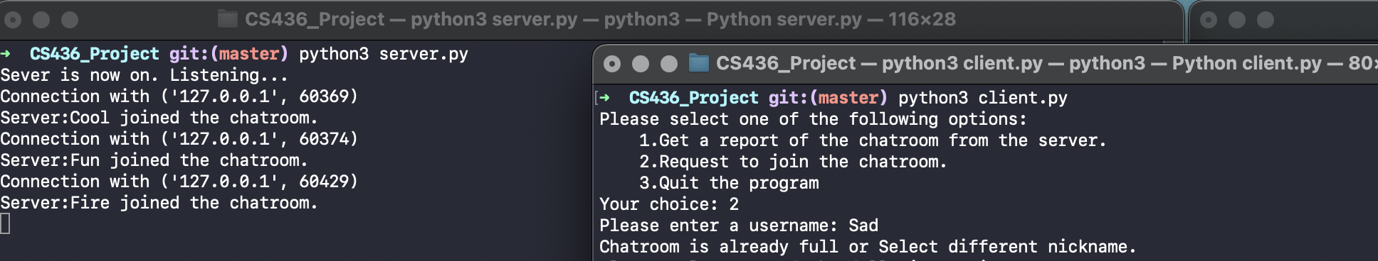

Step 7:

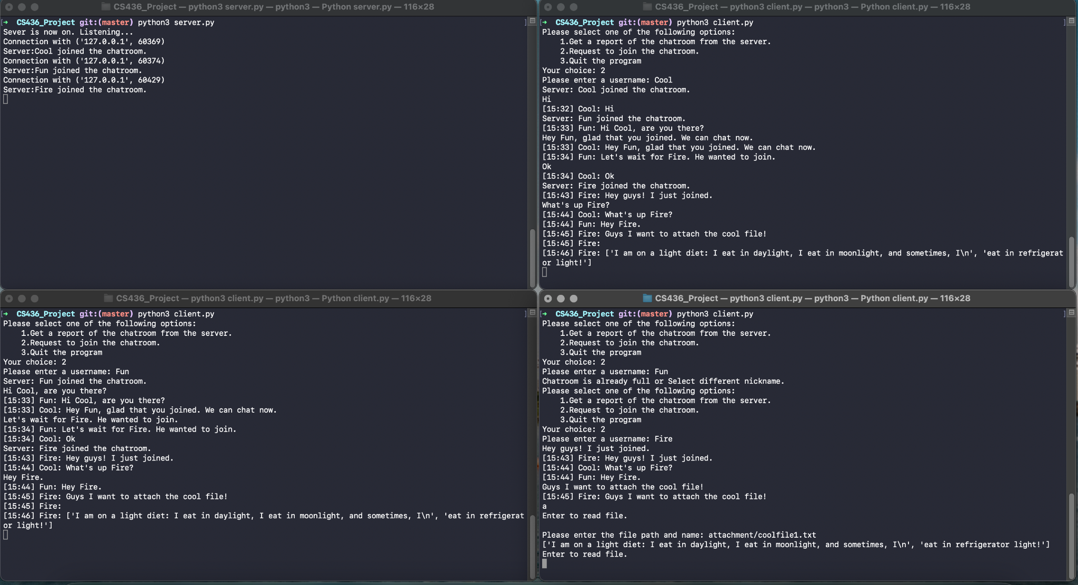

Step 8:

Command “q” worked, but server.py got an error.

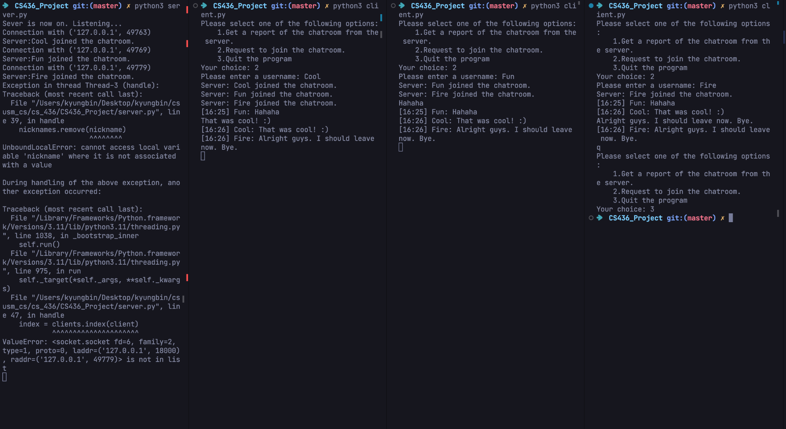

Step 9:

